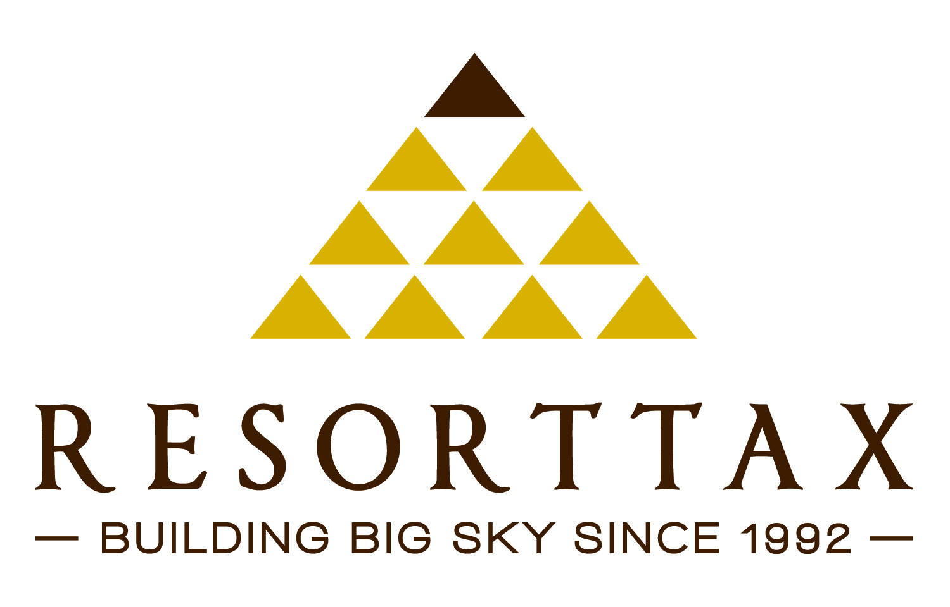

BIG SKY COMMUNITY ORGANIZATON QUESTIONNAIRE

Download online: www.bigskyresorttax.com | Submit to: info@bigskyresorttax.com

This survey requests information on each Resort Tax Applicant organization’s goals, needs, and challenges, which includes funding and cash flow requirements for at least the next three years along with the most current fiscal year’s financial summary. During the first town hall meeting on January 14th, the survey will be reviewed and any questions answered as to information requested. The survey needs to be returned to the Tax District office by February 1st. Projecting future community collective demands on the tax funds in a written piece will be informative to all and helpful to our discussions at the second town hall meeting February 11th.

Organization Name:

Qualified for Resort Tax Funding: □Yes □No □Don’t know

Mission Statement:

Most Recent Completed Fiscal Year Budget: □2011 OR □2012

PRINCIPLE | ITEM | AMOUNT
Revenue | Private Donor Contributions Total
 | Private Donor Contributions In-kind
 | Public Grants
 | Fundraising Events
 | Other
 | Total Revenue
Expenses | Personnel  (not including volunteer time)
 | Operations
 | Programming
 | Other
 | Total Expenses
Income | Net Income

Capital Reserves | On Hand Restricted
 | On Hand Unrestricted
 | Goal

Other Description:

Cash Flow 3-Yr Requirement | ITEM | 2013 | 2014 | 2015
Personnel
(not including volunteer time)
 | Operations
 | Programming
 | Capital Expenditures
 | Other
 | Total Cash Flow for 3-Years

RESORT TAX REQUEST

Describe financial increases and decreases and the projects for which resort tax funds may be requested.

2013

2014

2015

